**PIZZA SALES SQL QUERIES**

**A. KPI’s**

**1. Total Revenue:**

SELECT SUM(total_price) AS Total_Revenue FROM pizza_sales;

***Output:***

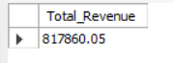

**2. Average Order Value**

SELECT (SUM(total_price) / COUNT(DISTINCT order_id)) AS Avg_Order_Value FROM pizza_sales;

***Output:***

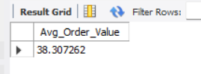

**3. Total Pizzas Sold**

SELECT SUM(quantity) AS Total_Pizza_Sold FROM pizza_sales;

***Output:***

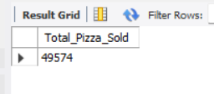

**4. Total Orders**

SELECT COUNT(DISTINCT order_id) AS Total_orders FROM pizza_sales;

***Output:***

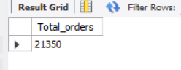

**5. Average Pizzas Per Order**

SELECT CAST(CAST(SUM(quantity) AS DECIMAL(10,2)) /

CAST(COUNT(DISTINCT order_id) AS DECIMAL(10,2)) AS DECIMAL(10,2))

AS Avg_Pizzas_per_order

FROM pizza_sales;

***Output:***

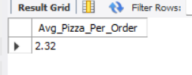

**B. Daily Trend for Total Orders**SELECT DAYNAME(order_date) AS Order_Day, COUNT(DISTINCT order_id) AS Total_orders

FROM pizza_sales

GROUP BY DAYNAME(order_date);

***Output:***

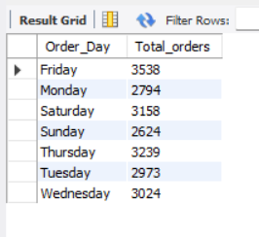

**C. Monthly Trend for Orders**

SELECT MONTHNAME(order_date) AS Month_Name, COUNT(DISTINCT order_id) AS Total_orders

FROM pizza_sales

GROUP BY MONTHNAME(order_date)

ORDER BY Total_orders DESC;

***Output:***

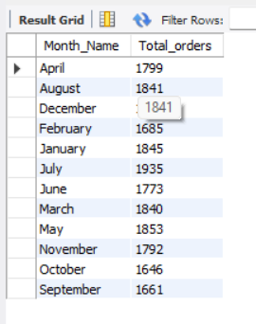

**D. % of Sales by Pizza Category**

SELECT pizza_category, SUM(total_price) AS Total_Sales ,SUM(total_price) * 100 / (SELECT SUM(total_price) FROM pizza_sales) AS PCT

FROM pizza_sales

GROUP BY pizza_category;

***Output:***

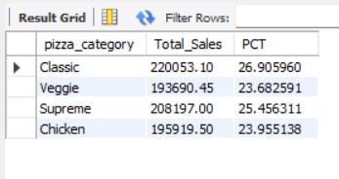

**E. % of Sales by Pizza Size**

SELECT pizza_size, CAST( SUM(total_price) AS DECIMAL(10,2)) AS Total_Sales ,CAST(SUM(total_price) * 100 / (SELECT SUM(total_price) FROM pizza_sales) AS DECIMAL(10,2))AS PCT

FROM pizza_sales

GROUP BY pizza_size

ORDER BY PCT DESC;

***Output:***

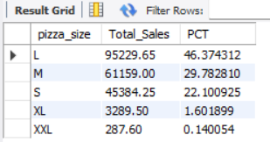

**F. Total Pizzas Sold by Pizza Category**

SELECT pizza_category, SUM(quantity) as Total_Quantity_Sold

FROM pizza_sales

GROUP BY pizza_category

ORDER BY Total_Quantity_Sold DESC

***Output:***

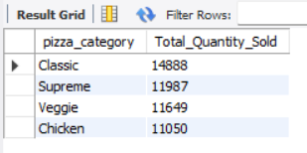

**G. Top 5 Pizzas by Revenue**

SELECT pizza_name, SUM(total_price) AS Total_Revenue FROM pizza_sales

GROUP BY pizza_name

ORDER BY Total_Revenue DESC

limit 5;

***Output:***

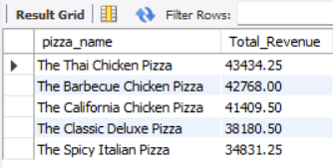

**H. Bottom 5 Pizzas by Revenue**

SELECT pizza_name, SUM(total_price) AS Total_Revenue FROM pizza_sales

GROUP BY pizza_name

ORDER BY Total_Revenue ASC

limit 5;

***Output:***

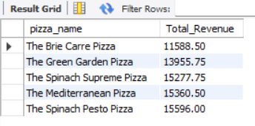

**I. Top 5 Pizzas by Quantity**

SELECT pizza_name, SUM(quantity) AS Total_Quantity FROM pizza_sales

GROUP BY pizza_name

ORDER BY Total_Quantity DESC

LIMIT 5;

***Output:***

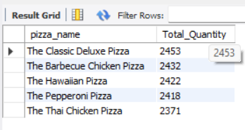

**J. Bottom 5 Pizzas by Quantity**

SELECT pizza_name, SUM(quantity) AS Total_Quantity FROM pizza_sales

GROUP BY pizza_name

ORDER BY Total_Quantity ASC

LIMIT 5;

***Output:***

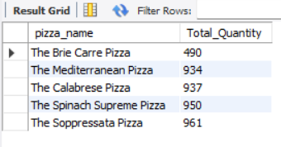

**K. Top 5 Pizzas by Total Orders**

SELECT pizza_name, COUNT(DISTINCT order_id) AS Total_Orders FROM pizza_sales

GROUP BY pizza_name

ORDER BY Total_Orders DESC

LIMIT 5;

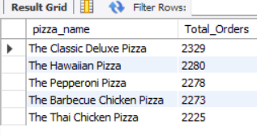

**L. Bottom 5 Pizzas by Total Orders**

SELECT pizza_name, COUNT(DISTINCT order_id) AS Total_Orders FROM pizza_sales

GROUP BY pizza_name

ORDER BY Total_Orders ASC

LIMIT 5;

